**ARYAMAN MISHRA**

**19BCE1027**

**LAB 04**

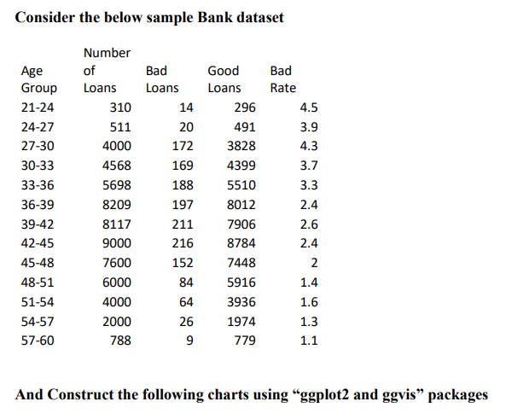

**library(ggplot2)**

**library(ggvis)**

**df=read.csv("C:\\Users\\aryam\\Desktop\\Fall Sem 2021\\Data Visualization Lab\\LAB 4 24-8-21\\Book1.csv")**

**ggplot(df, aes(x = Age_Groups,y = Number_of_Loans))+ geom_bar(stat='identity')**

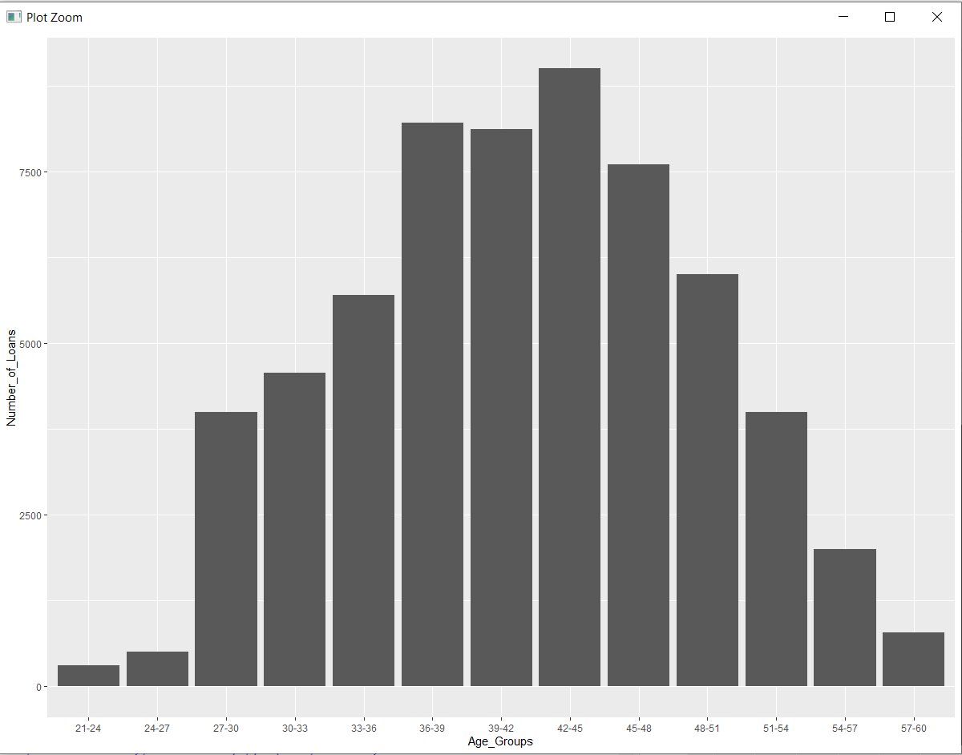

**ggplot(df, aes(x = Age_Groups,y = Bad_Rate, group = 1))+ geom_line(color = "orange")+**

**geom_line( aes(y=Bad_Rate), size=3, color="orange")**

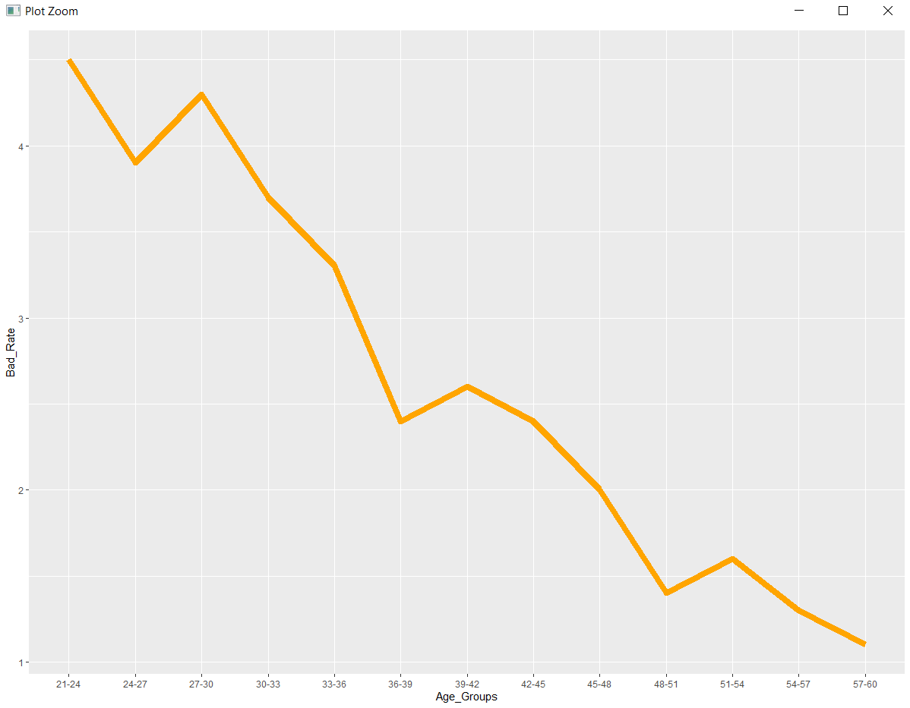

**ggplot(df) + geom_bar(aes(x=Age_Groups, y=Number_of_Loans),stat="identity")+**

**geom_line(aes(x=Age_Groups, y=Bad_Rate*2000,color="Bad Rate"),stat="identity",group = 1, size=1.3)+**

**scale_colour_manual("", breaks = c("Bad Rate"), values = c("orange")) +**

**scale_y_continuous(sec.axis = sec_axis(~ . / 2000, name = "Bad Rate"))**

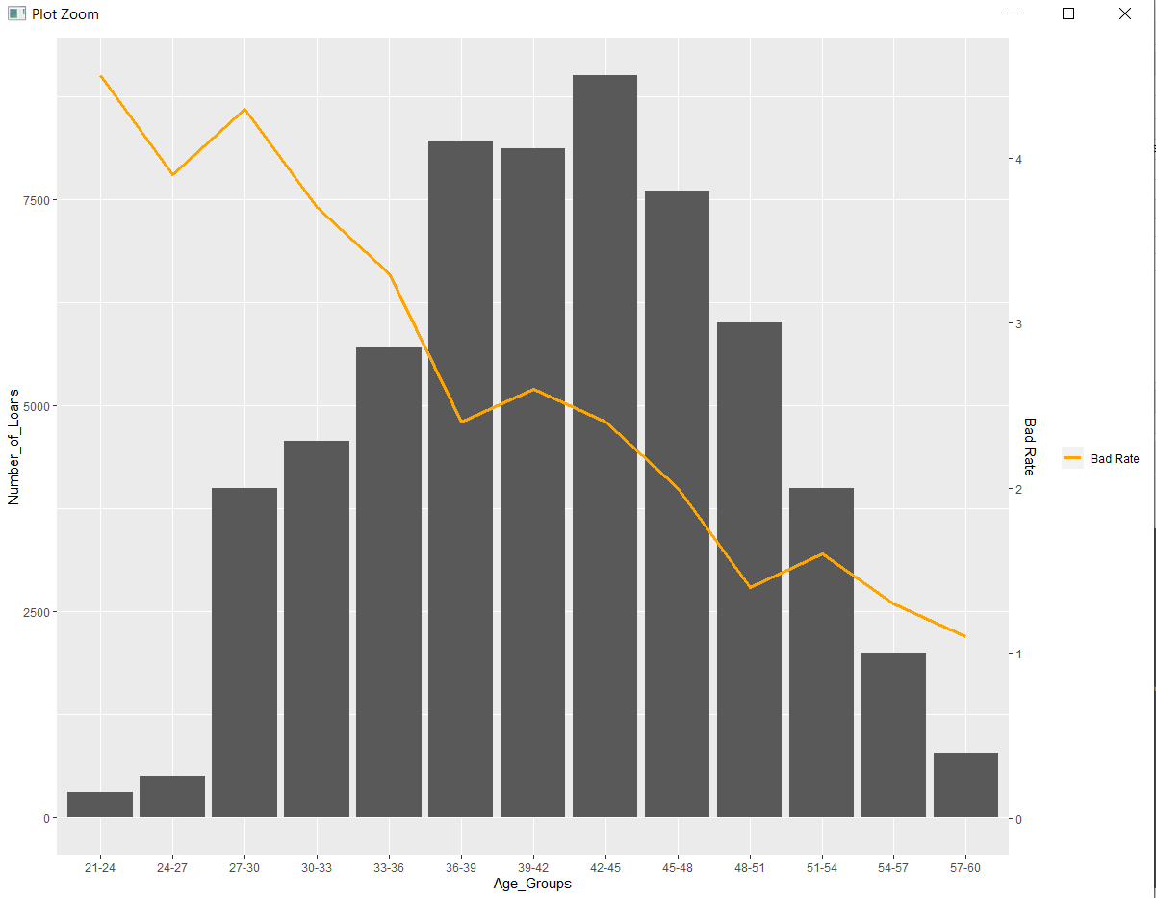

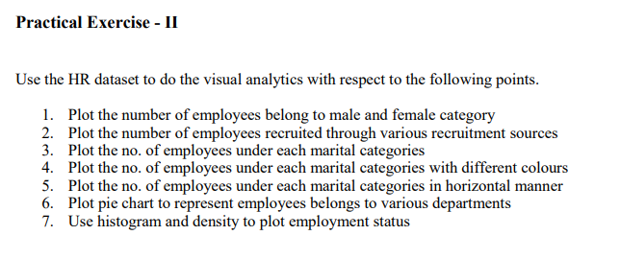

**library(ggplot2)**

**df=read.csv("C:\\Users\\aryam\\Desktop\\Fall Sem 2021\\Data Visualization Lab\\LAB 4 24-8-21\\HRDataset_v14.csv")**

**ggplot(df, aes(x= Sex,fill=Sex)) + geom_bar()**

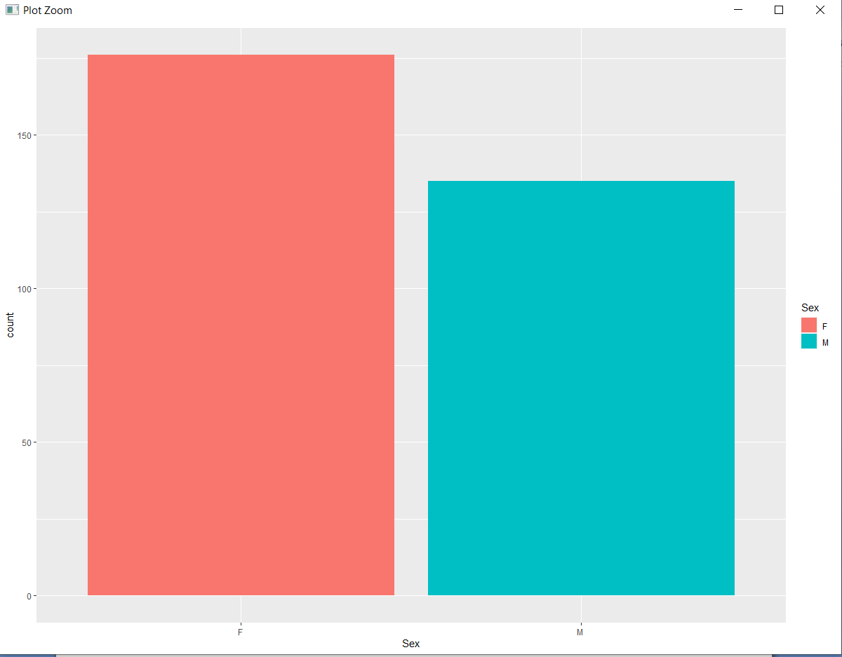

**ggplot(df, aes(x= RecruitmentSource,fill=RecruitmentSource)) + geom_bar()**

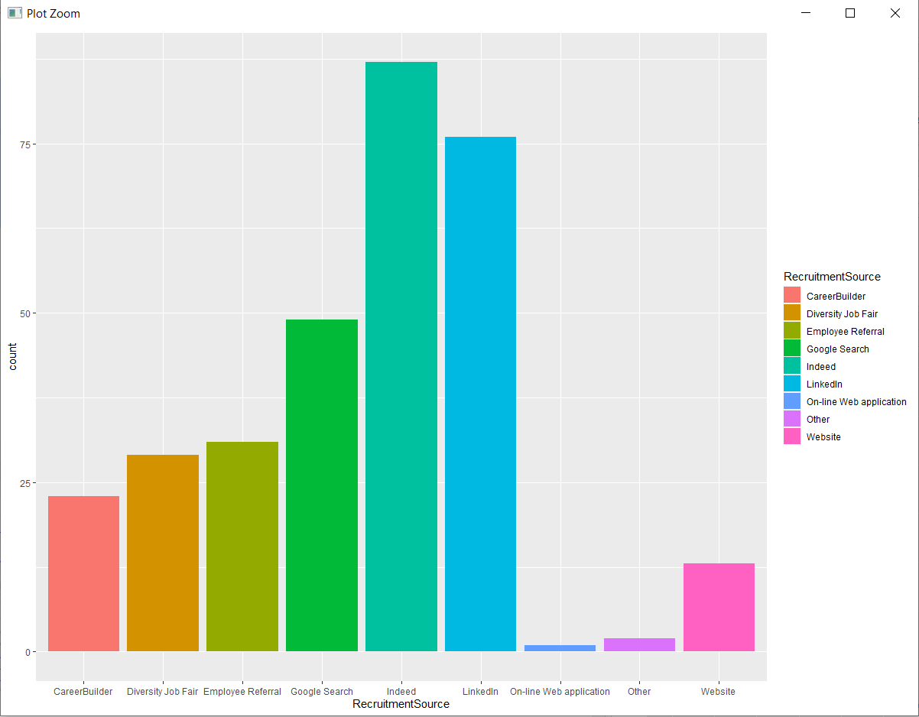

**ggplot(df, aes(x= MaritalDesc)) + geom_bar()**

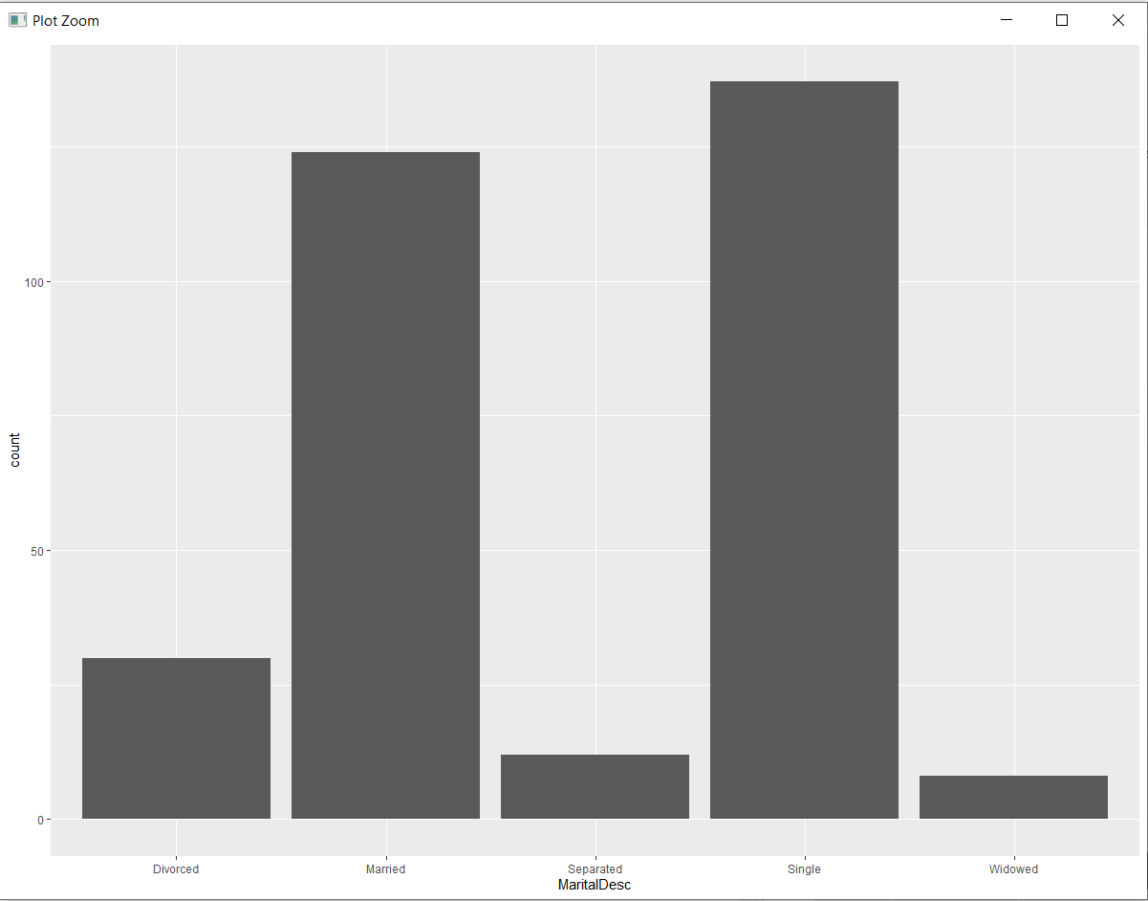

**ggplot(df, aes(x= MaritalDesc,fill=MaritalDesc)) + geom_bar()**

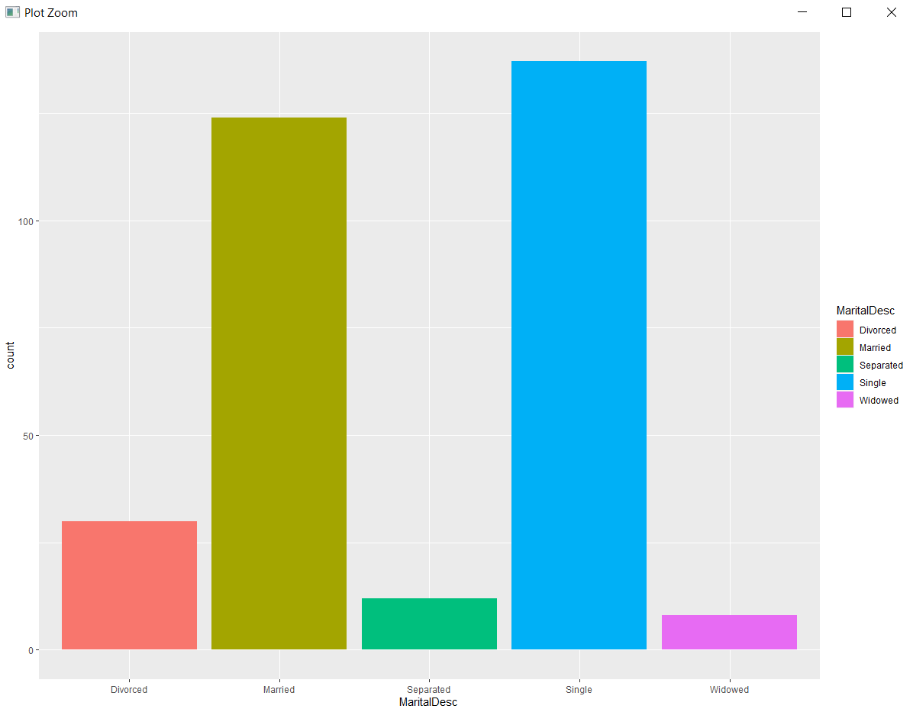

**ggplot(df, aes(x= MaritalDesc,fill=MaritalDesc)) + geom_bar()+ coord_flip()**

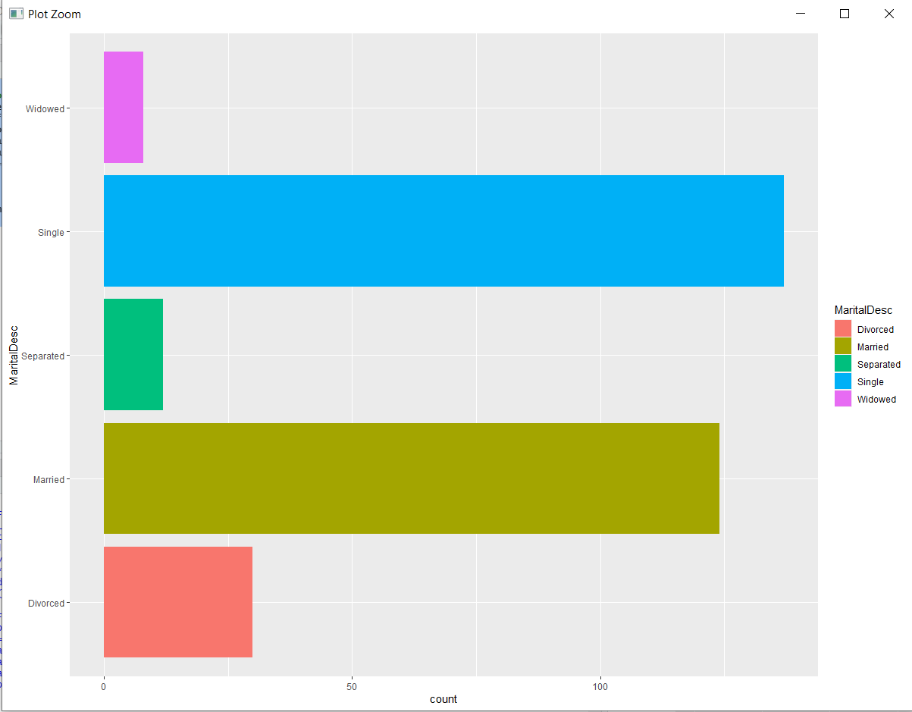

**ggplot(df, aes(x = factor(""), fill = Department))+ geom_bar()+**

**coord_polar(theta = "y") +**

**scale_x_discrete("")**

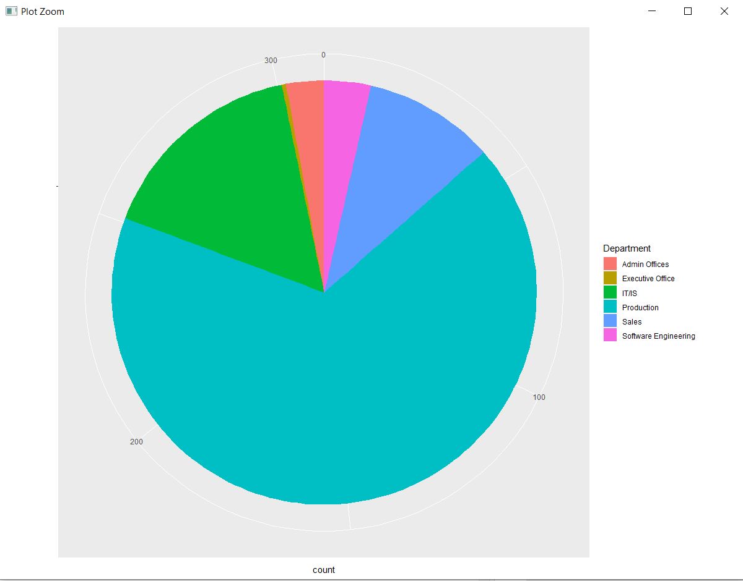

**ggplot(df, aes(EmpStatusID) ) +**

**geom_histogram(color="red",binwidth = 0.2, aes(EmpStatusID, ..density..))+ geom_density()**

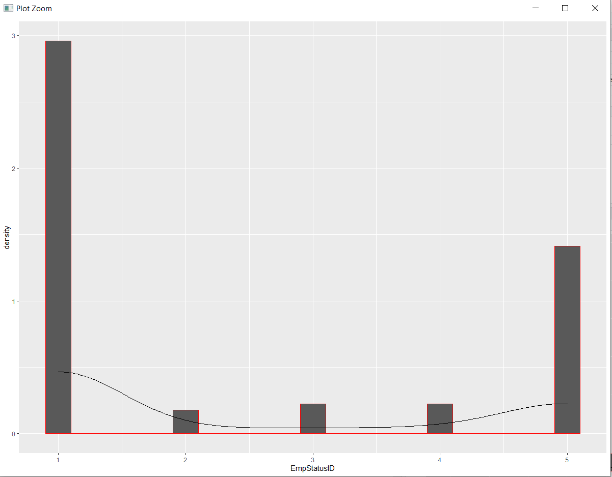

**CONCLUSION:ALL PRACTICAL EXERCISES HAVE BEEN SUCCESSFULLY EXECUTED.**